Practice 10. Periodic table questions. Name ________________________ Period_______Date_____
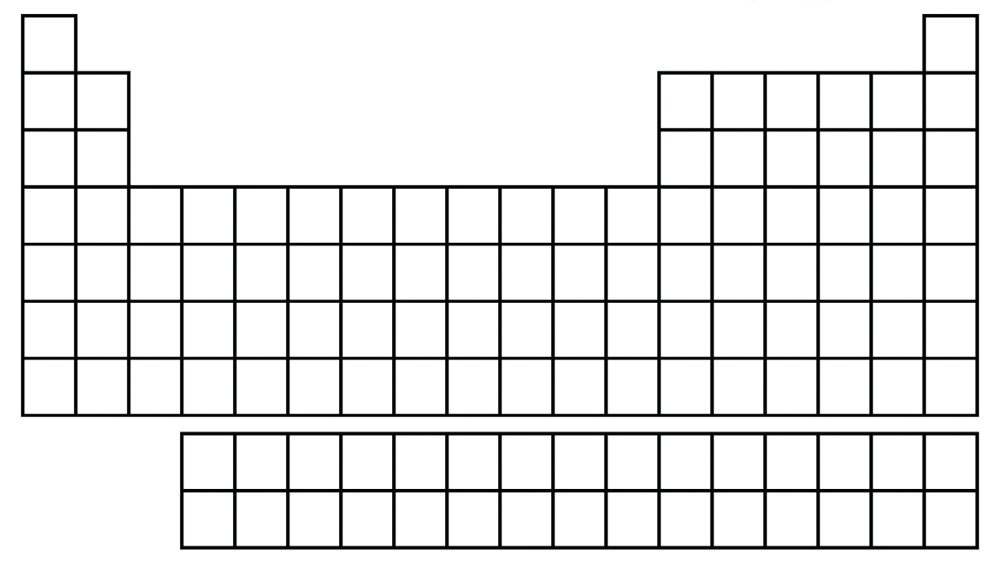
- Label to following groups, sections or periods of the periodic table: Alkali metals, Halogens, Noble gases, transition metals, metalloids.
1. Without using the periodic table, determine the group, period, and block of an atom with the following electron configurations.
a. [Ne]3s² b. [He]2s² c. [Kr]5s²4d¹⁰5p⁵

2. Write the electron configuration of the element fitting each of the following descriptions.
a. The group 2A element in the fourth period
b. The noble gas in the fifth period
c. The group 2B element in the fourth period
d. The group 6A element in the second period

3. What are the symbols for the elements with the following valence electron configurations?
a.s²d¹ b. s²p³ c. s²p⁶

4. Explain why elements in the same group on the periodic table have similar chemical properties.

5. Given each of the following valence electron configurations, determine which block of the periodic table the element is in. a. s²p⁴ b. s¹ c. s²d¹ d. s²p¹

6. Describe how each of the following are related.
a. Group number and number of valence electrons for representative elements
b. Principal energy level of valence electrons and period number

7. Without using the periodic table, determine the group, period, and block of an atom with an electron configuration of [Ne] 3s²3p⁴.

8. Based on the following electron configurations, identify each element as a representative, transition metal or noble gas:
a. 1s²2s²2p⁶3s²3p⁶3d¹⁰4s²4p⁶
b. 1s²2s²2p⁶3s²3p⁶3d⁶4s²
c. 1s²2s²2p⁶3s²3p²

